Gaelscoil Chill Dara

04.12.2019 | 04.12..2019
Cad a bhí ar siúl againn an tseachtain seo?  - Aonach na Leabhar! Míle buíóchas do Chomhairle na dTuismitheoirí agus gach uile dhuine a bhí bainteach leis an Aonach! Bhain gach éinne idir óg agus aosta sult agus tairbhe as.  - Tháinig Daidí na Nollag ar a bhealach go dtí Osipeál Ollscoile na Leanaí, Sráid an Teampaill.  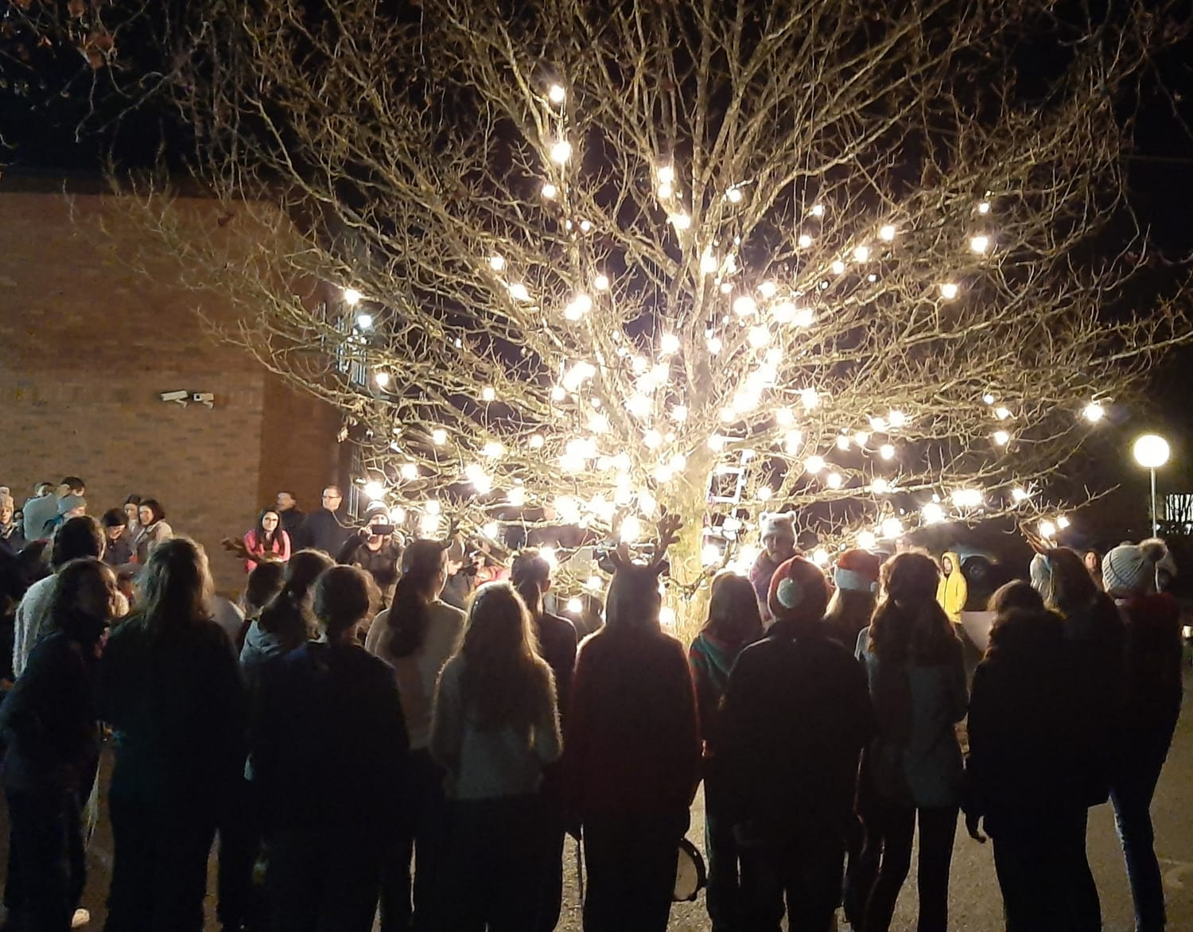  - D’imigh buachaillí ó Rang 6 le Múinteoir Cáit go comórtas sacair i Scoil Uí Riada, Cill Choca.. | What were we doing this week?  - Book fair! A Huge thank you to the Parent’s committee and everyone that was involved in the fair. Everyone from young and old enjoyed it immensely.  - Daidí na Nollag came to visit us yesterday on his way to Children's University Hospital, Temple Street.  - The boys from sixth class and Múinteoir Cáit went to a soccer blitz Scoil Uí Riada, Kilcock and had a great time
Eolas do thuismitheoirí  - Táimid ag obair go dian ag ullmhú don Nollag agus ag obair ar an gclár Bí Sabháilte. Is féidir a thuileadh eolais a fháil anseo!  - Tá an dáta deiridh don chlárúchán 2020 ag teacht. Bí cinnte go bhfuil na foirmeacha do na páistí nua againn ar an 15.12.2019 ar a deireanaí.  - Drámaí na Nollag -Eolas roinnte ar Aladdin leis na ranganna atá bainteach leo!  - Féilire na scoile ar fáil san oifig. 10 euro an cheann nó 16 do dhá fhéilire!  - Cóisir Dhaidí na Nollag - Gaelscoil Nás na Riogh, 11.00, 15.12.2019. Cláraighg ainm & aois do pháiste (0-7) tuismitheoir@sultnasollain.ie  . | Information for Parents  - We are working hard to prepare for Christmas and also working on the Stay safe programme. Find more information here!  - It is coming toward the end of 2020 enrollment. Please be sure you have forms in by 15.12.2019 at the latest.  - Christmas plays - information to be shared on Aladdin by the relevant classes.  - School calendar is now available for the school office - €10 per calendar or €16 for two!  - Santa’s party - Gaelsclil Nás na Ríogh, 11.00, 15.12.2019. Register your child’s name and age at tuismitheoir@sultnasollain.ie
Dátaí dod’ dhialann  - Laethanta saoire na Nollag 12.00 ar an Aoine 20 Nollaig 2019. Beidh cead ag na páistí a rogha éadaí a chaitheamh ar an lá agus baileoimid dhá euro an duine nó 5 euro do 3r um airgead a thiomsú do chartanacht sa cheantar - Hope D  - Athoscailt na Scoile 6.01.2020 ag 9 a chlog ar maidin.  - Cruinnithe leis na múinteoirí 21,22,23.01.2020. | Dates for your diary  - Christmas holidays start at 12.00 on friday, 20th December. Children will be allowed to wear their own clothes on the day and we will collect €2/€5 per family to raise funds for Hope D.  - We will reopen at 9.00 on Monday, 6th January 2020.  - Parent/teacher meetings 21,22 & 23.01.2020
Gaeilgeoirí na Seachtaine agus Réaltaí an Lae- agus Buaiteoirí sna Comórtais Ealaíne!  Comhghairdeachas Libh agus le Múinteoir na Seachtaine - Múinteoir Eunice | Gaeilgeoirí na Seachtain agus Réaltaí na Seachtaine - Congratulations to you all! Múinteoir na seachtaine – Múinteoir Eunice

